|  |
| --- |
|  |
| **Evaluative study on the interactive ability of phenolic acids derived from pomegranate peel with Cu2+ ions as examined using UV-Vis spectroscopy** |
| How do phenolic acid derivatives obtained from pomegranate peel interact with Copper (II) ions? |
|  |
|  |
| **Word Count: 5906** |

|  |
| --- |
|  |

Contents

1 Abbreviation Chart 5

2 Introduction and Rationale 6

3 Research Question 7

4 Background Information 8

4.1 Copper 8

4.2 Ligands and Colored Complexes 8

4.3 Denticity and Chelation 11

4.5 Polyphenols present in PP 12

4.6 Thermodynamics in Chelation 14

4.7 Effect of Solvent 16

4.8 Effect of pH Environment 17

4.9 Determination of Extent of Interaction 19

5 Hypothesis 20

5.1 Hypothesis 1 – Solvent Performance 20

5.2 Hypothesis 2 – Effect of PPP Mass Used 20

5.3 Hypothesis 3 – Effect of Metal Ion concentration 20

5.4 Hypothesis 4 – Effect of Metal Ligand Voluminal Ratio 21

5.5 Hypothesis 5 – Effect of pH Environment 21

6 Preliminary Investigations 21

6.1 Selection of Extraction Method 21

6.2 Selection of Boiling Duration 22

6.3 Selection of Solvents 22

6.4 UV-Vis Spectroscopy 22

6.4.1 Lambda Max Determination 22

6.4.2 Standard Calibration Curve 23

7 Variables 24

7.1 Independent 24

7.2 Dependent 24

8 Preparation of Reagents 24

8.1 Preparation of CuSO4 standards of varying concentrations 24

8.2 Preparation of ligand solutions 25

8.3 Preparation of complex solutions 25

8.4 Preparation of pH 2 buffer 25

8.4.1 Reagent 1 Preparation (0.20 moldm-3 Hydrochloric Acid) 25

8.4.2 Reagent 2 Preparation (0.20 moldm-3 Potassium Chloride) 26

8.4.3 Buffer Preparation 26

8.5 Preparation of pH 5 buffer 26

8.5.1 Reagent 1 Preparation (0.10 moldm-3 Glacial Acetic Acid) 26

8.5.2 Reagent 2 Preparation (0.10 moldm-3 Sodium Acetate Trihydrate) 27

8.5.3 Buffer Preparation 27

8.6 Preparation of pH 7 buffer 27

9 Data Collection 27

9.1 Qualitative Data 28

9.1.1 Complex Solutions for Varying Solvents 28

9.1.2 Complex Solutions at Varying PPP Mass (± 0.001) (g) 28

9.1.3 Complex Solutions at Varying Copper Concentrations (moldm-3) 28

9.1.4 Complex Solutions at Varying Solution:Cu2+ Voluminal Ratios (cm3) 29

9.1.5 Complex Solutions at Varying pH and PPP Mass (± 0.001) (g) 29

9.1.6 Complex Solutions at Varying pH and Voluminal Ratios (cm3) 29

9.2 Quantitative Data – Absorbance Value 30

9.2.1 Complex Solutions for Varying Solvents 30

9.2.2 Complex Solutions at Varying PPP Mass (± 0.001) (g) 30

9.2.3 Complex Solutions at Varying Copper Concentrations (moldm-3) 30

9.2.4 Complex Solutions at Varying Solution:Cu2+ Voluminal Ratios (cm3) 31

9.2.5 Complex Solutions at Varying pH and PPP Mass (± 0.001) (g) 31

9.2.6 Complex Solutions at Varying pH and Voluminal Ratios (cm3) 31

10 Data Processing – IE% 32

10.1 Complex Solutions for Varying Solvents 32

10.2 Complex Solutions at Varying PPP Mass (± 0.001) (g) 32

10.3 Complex Solutions at Varying Copper Concentrations (moldm-3) 33

10.4 Complex Solutions at Varying Solution:Cu2+ Voluminal Ratios (cm3) 33

10.5 Complex Solutions at Varying pH and PPP Mass (± 0.001) (g) 33

10.6 Complex Solutions at Varying pH and Voluminal Ratios (cm3) 34

11 Analysis 34

11.1 Analysis 1 – Solvent Performance 34

11.2 Analysis 2 – Effect of PPP Mass Used 35

11.3 Analysis 3 – Effect of Metal Ion concentration 36

11.4 Analysis 4 – Effect of Metal Ligand Voluminal Ratio 36

12 Conclusion 37

13 Evaluation 37

13.1 Strengths 37

13.2 Weaknesses 37

14 Further Scope 38

15 References 38

16 Appendix 42

16.1 Uncertainties 42

16.1.1 Varying copper standards 42

# 1 Abbreviation Chart

|  |  |
| --- | --- |
| **Abbreviation** | **Explanation** |
| **PP** | pomegranate peel |
| **PPP** | pomegranate peel powder |
| **EDTA** | Ethylenediaminetetraacetic acid |
| **GA** | Gallic acid |
| **EA** | Ellagic acid |
| **IE** | interaction efficiency |

# 2 Introduction and Rationale

Ensuring access to clean water for everyone is one of the UN’s Sustainable Development Goals (United Nations). Nearly 800 million people worldwide lack reliable access to clean drinking water (Water.org). Unequal access to clean drinking water is estimated to cost the world around $260 billion USD annually (Water.org). One of the main causes for the contamination of water is due to wastewater effluent from factories which dangerously increase the amount of heavy metals such as Copper in the waterways. (Mokarram, Saber and Sheykhi). The deleterious effects of heavy metal poisoning of drinking water are well documented and known - heavy metal contamination can lead to the development of cardiovascular diseases, neuron damage, and an increased risk of cancer and diabetes (Rehman, Fatima and Waheed).

The conventional EDTA filtering method for remediating heavy metal contaminated water that was taught in Chemistry class is efficient (due to its hexadentate nature) but EDTA’s resistance to bacterial biodegradation (Hinck, Ferguson and Puhaakka) and the adverse effects of its complexes (Crisponi, Nurchi and Lachowicz) nullifies its effectiveness in today’s eco-conscious world. Hence research has been undertaken in order to find sustainable, low-cost, organic sources of chelating agents such as pomegranate peels. (Rashed and Tayh).

Pomegranates are enjoyed by many across the world, thanks to their taste and numerous health benefits (Zarfeshany, Asgary and Javanmard). However, PPs, which consist of approximately 30% of the whole fruit’s weight (Mo, Ma and Gao), are generally discarded, even though they have been identified as a valuable source for organic substances (Figure 1).

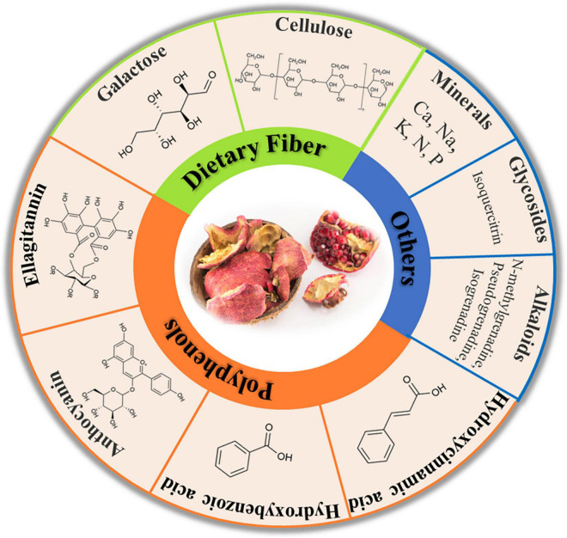

*Figure 1: Some bioactive compounds present in PPs* (Mo, Ma and Gao)

Hence, due to their high polyphenolic content, PPs can be used for treating heavy metal contaminated water through interactions between the polyphenolic compounds and the metal ions such as copper (II) ions. The aim of this study is to determine the most efficient method to extract the various phenols present in PPP by using various extraction methods and solvents.

# 3 Research Question

This led me to formulate the research question – **How do phenolic acid derivatives obtained from pomegranate peel interact with Copper (II) ions?**

The study explores the optimal mass of PPP, solvent, metal ion concentration, metal-ligand ratio, and pH environment which yields the highest IE. To understand the interactions between the phenolic derivatives and the copper (II) ions, we need to look into the individual components.

# 4 Background Information

## MolView (structural formula).png4.1 Copper

In the center of the interaction is the metal ion, copper. Located in the d-block of the periodic table, it is a transition metal with a unique electronic configuration of [Ar]4s13d10. This configuration is taken by the copper atom as it is more stable having an incomplete s-orbital than an incompletely filled d-orbital (Brown and Ford). Copper can exist in two oxidation states including as Cu+, however, it is most commonly found as Cu2+with the loss of one electron from the outermost 4s-subshell and the loss of another electron from the 3d-subshell. In its more stable +2 oxidation state, copper ions have a maximum of six binding sites as shown in Figure 2.

*Figure 2: The octahedral structure of the complex [Cu(H2O)]6 ]2+ (Hexaaquacopper(II))* (MolView)

Although essential for bone and cardiovascular health (Araya, Olivares and Pizarro), copper has been linked to several adverse effects in the body (Manne, Kumaradoss and Iska). It is mainly introduced into the body through water (Manne, Kumaradoss and Iska) – which is the motive behind this research in reducing copper content in water.

## 4.2 Ligands and Colored Complexes

Before moving onto the properties of the aforementioned phenolic derivatives, we must first understand what they are in this experiment – ligands. Metal ions and ligands participate in Lewis Acid/Base interactions through electron pair donation by the ligands, leading to the formation of coordination complexes. This interaction lifts the degeneracy of the metal ion's d-orbital, resulting in the formation of t2g and eg sub-levels. The energy difference between these sub-levels is influenced by both the metal-ion and ligand properties. This determines the wavelength of light which is absorbed by the complex solution, thus resulting in the complementary color being seen. This process is visually detailed in Flowchart 1.

The color of metal complexes is determined by the extent to which the d-orbitals are split. The spectrochemical/ligand strength series (Figure 4) arranges ligands on an arbitrary scale, arranged in the increasing order of their ability to split the energy levels of the metal atoms.

|  |
| --- |
| **I−< Br−< S2−< Cl−< F− < OH−< H2O < SCN−< NH3< CN−< CO**  *Figure 4: Spectrochemical Series* |

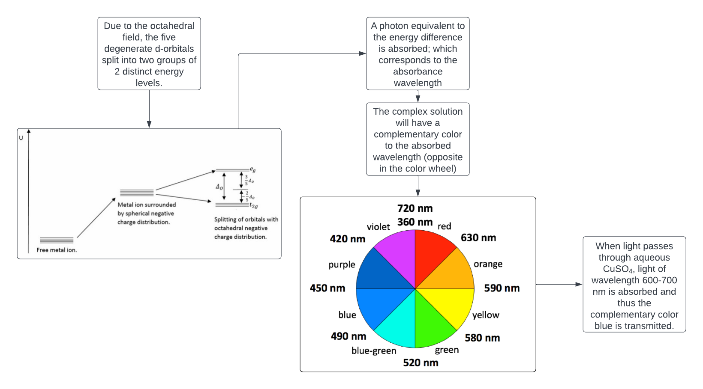

*Flowchart 1: The process of d-d splitting by the octahedral field and the formation of colored complexes* (Lucidchart)(LibreTexts)

Flowchart 1

*: The process of d-d splitting by the octahedral field and the formation of colored coordinate complexes* (Lucidchart)

## 4.3 Denticity and Chelation

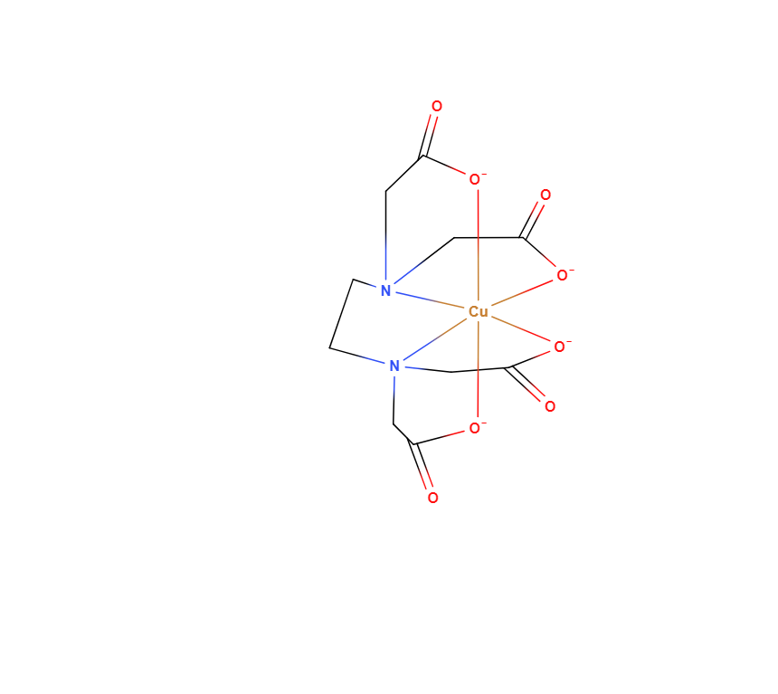Ligands are classified by two factors, their denticity and strength. Denticity is a characteristic of a ligand’s binding site(s). For example, as seen is Figure 3, when a hexadentate ligand like EDTA approaches a transition metal, multiple dative bonds are formed between the metal ion and the binding sites of the ligand. This process is a special type of complexation called chelation.

Having origins from the Greek word for ‘claw,’ (Flora and Pachauri) chelation differs from complexation by the denticity of the participating ligands. Monodentate ligands like water offer only one binding site, leading to complexation as seen in Figure 2. Polydentate ligands (also known as chelating agents) meanwhile interact with the central metal ion through multiple binding sites (such as in Figure 3); thus, leading to chelation. Chelating agents wrap around the metal ion, forming ring-like/cage-like structures called chelate complexes or chelates which boost the stability of the complex - this is referred to as the chelate effect (Lancashire). This is the primary type of interaction that takes place between the copper (II) ions and the phenolic extracts from PPP as detailed in the following section.

*Figure 4: Structure of the complex [Cu(EDTA)]2−* (MolView)

Going back to EDTA, although effective in its role of scavenging heavy metals, especially copper (Lo and Yang), EDTA (in the form of Na2EDTA and CaNa2EDTA) has been found to lead to health complications regarding the homeostasis of metal ion concentrations in the body (Crisponi, Nurchi and Lachowicz). This, combined with the growing proliferation of sustainable nature-based substitutes for synthetic chemicals in industry has led me to explore the use of PPs in the filtration of heavy metal contaminated water.

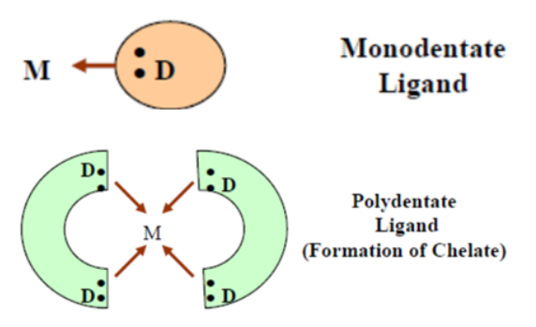

*Figure 7: Pictorial representation of complexation (top) and chelation (bottom)* (Flora and Pachauri)

## 4.5 Polyphenols present in PP

Phenolic compounds, such as polyphenols, are a major group of compounds which have been recognized for their contribution to our health (Belščak-Cvitanović, Durgo and Huđek). They are characterized by the presence of multiple phenol groups in the molecule, thus making them effective natural metal chelating agents (Belščak-Cvitanović, Durgo and Huđek). There are many polyphenolic compounds present in PPs, from tannins and flavonoids to various phenolic acids (Mo, Ma and Gao); the primary ones identified being GA and EA (which constitute approximately 60-80% of the total phenolic content) (Kupnik, Leitgeb and Primožic).

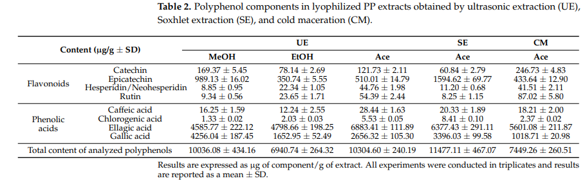

*Figure 8: Chemical constituents of PPP extracts* (Kupnik, Leitgeb and Primožic)

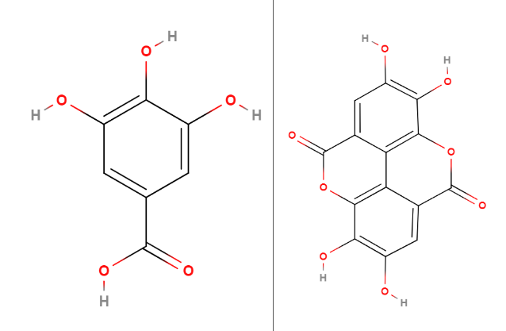

*Figure 9: Molecular structures of two major polyphenolic constituents of PP, GA and EA (right to left)* (MolView)

The multiple hydroxyl and carboxyl groups on the GA and the hydroxyl groups on the EA can donate electrons to the Cu2+ ions. GA can only undergo complexation as the oxygen atom in central hydroxide group cannot form multiple dative bonds. EA on the other hand can undergo chelation with copper as it has four hydroxide groups. This is shown inFigure 9.

These two ligands, along with other phenols (Figure 6), contribute to the PP’s ability to treat heavy metal contaminated water. This prompted me to explore PPs further and their role in the process of water filtration. Now, the thermodynamic specificities of the interaction between the ligands and copper will be elaborated.

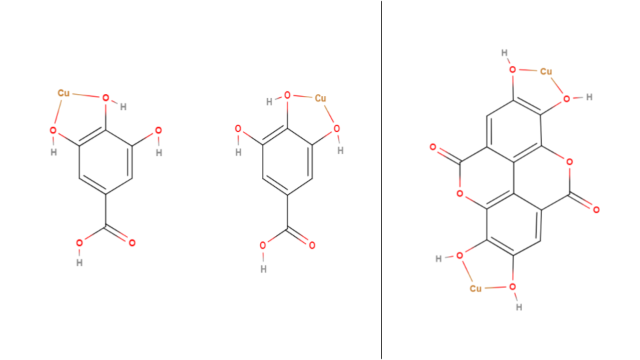

*Figure 10: The possible copper complexes that can form with GA (left and center) and EA (right).*

## 4.6 Thermodynamics in Chelation

In an aqueous medium (through which most copper is ingested by the body (Manne, Kumaradoss and Iska)), copper (II) ions exist as the complex Hexaaquacopper (II) (Figure 2). This is due to the solvation/hydration enthalpy of water being stronger than the ionic bonds in CuSO4, thus resulting in the formation of Cu-hydrated complexes like the aforementioned one.

When a chelating agent like GA or EA approaches the complex, an associative substitution/ligand exchange mechanism comes into play as shown in Figure 8. This is a spontaneous reaction due to the negative Gibbs free energy for the reactions as the entropy increases due to the loss of multiple aqua ligands particles in the complex. Moreover, the chelate is more stable than the hydrated complex due to the aforementioned chelate effect.



*Figure 11: The transient state in the associative substitution mechanism for when the EA approaches and interacts with the copper atom as the aqua ligands disassociate* (MolView)

## 4.7 Effect of Solvent

Before the complexation and chelation processes can begin, ligands must first be extracted from the PPP. The solvent with the highest degree of interaction with the ligands will have the highest extraction efficiency and thus the most optimal IE values. The major factors affecting the interaction are the solvent’s polarity and intermolecular forces.

Firstly, the polarity of the solvent determines its ability to interact with the polar groups of GA and EA, namely the carboxylic acid group of GA and the hydroxide groups of the molecules. Polarity may play a lesser role in the solvation of EA than GA, which can be attributed to EA’s much higher molecular mass than GA (PubChem). A lower proportion of the overall mass is accounted for by the polar groups in EA than GA (as both have 4 hydroxide groups), and thus - although polarity plays a vital role in the solubility of these compounds in a solvent – the higher molecular mass of EA would result in lower extraction yields for it than GA in a polar solvent.

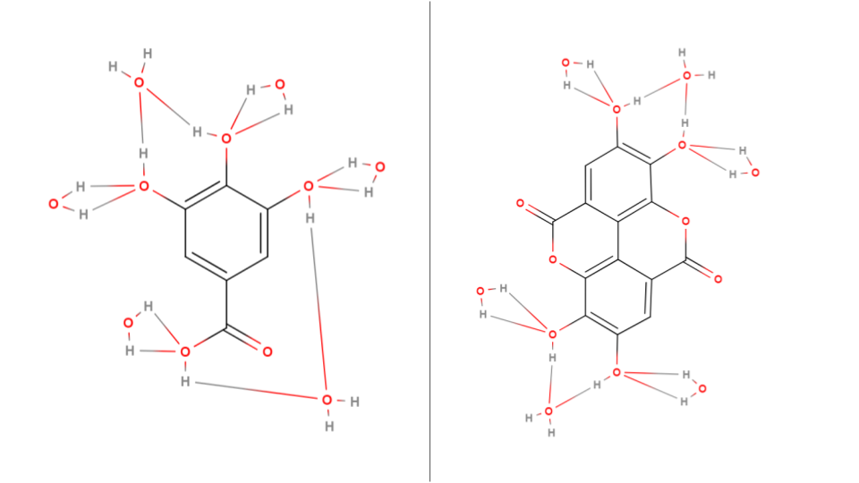

*Figure 12: An example of a hydrated cluster of GA (left) and EA (right). Water molecules form hydrogen bonds with the hydroxide groups in each ligand, dissolving it* (MolView)*.*

Secondly, although not as strong as the hydrogen bonding present in the polar interactions in GA and EA, the intermolecular van der Waals forces also hold the potential to impact a solvent’s solvation capabilities. A greater van der Waals interaction between the solvent and solute molecules translates to higher solvation efficiencies – especially in the case of EA which has large aromatic rings which tend to interact extensively with large, non-polar molecules through the aforementioned forces.

Literature data validates this - GA (Daneshfar, Ghaziaskar and Homayoun) and EA (Bala, Bhardwaj and Hariharan) are more soluble in methanol and ethanol than water (with ethanol being in the middle for both acids). Methanol, with its moderate polarity and surface area, balances both solubility factors and thus has the most optimal results. The superior performance of ethanol relative to water suggests that van der Waals forces play a more significant role in dissolving the ligands than polarity. This finding will be useful for the framing of the first hypothesis.

The selection of these solvents was based upon their high availability, low-cost, and low environmental impact, which connects with the sustainable focus of this study.

## 4.8 Effect of pH Environment

The pH of the complexation environment would play a significant role in the complexation efficiency. In alkaline conditions, the extracted GA will deprotonate to a greater degree (due to the presence of a carboxylic group). This leads to the ionization of the carboxylic group and an increase in the binding sites present in the chelator, making it more efficient in complexing with the copper ions as shown in Figure 13. However, the increased concentration of hydroxide ions (OH-) results in competition for the ligands, hence leading to the possible precipitation of copper, affecting complexation efficiency. Due to the absence of carboxylic groups in EA, the extent of deprotonation will be insignificant.

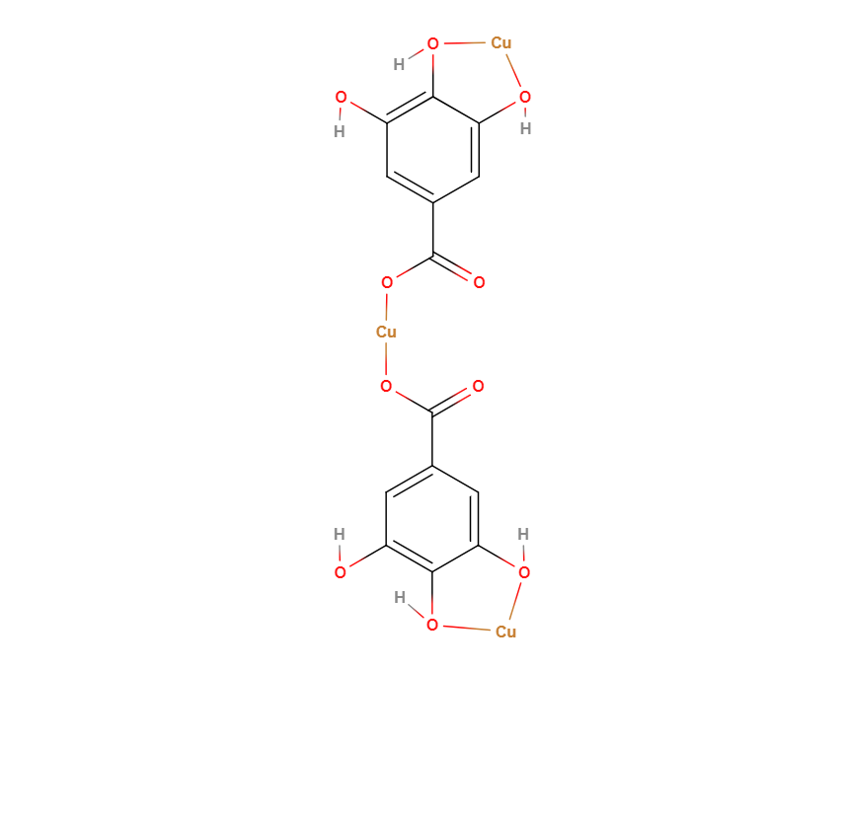

*Figure 13: Possible Cu-GA complex that may form in alkaline conditions. The deprotonation of the carboxylic group allows the singly-bonded oxygen to form a coordinate bond with the copper ion, resulting in a theoretical 50% increase in the IE (ignoring possible precipitation of copper)* (MolView)*.*

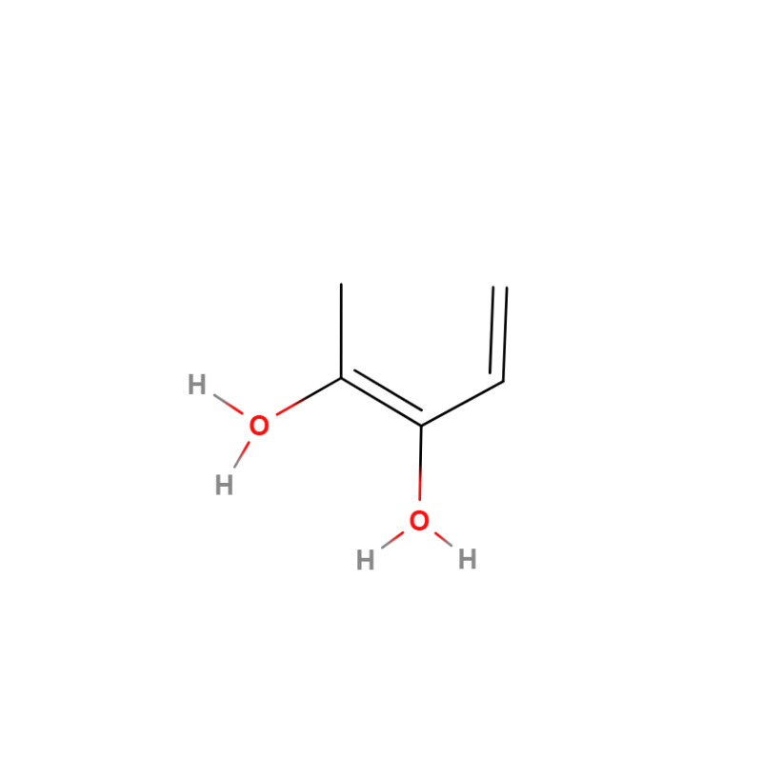The opposite effect is expected in acidic conditions. The increased protonation of the oxygen atom in the hydroxide groups (due to the temporary formation of a dative bond) present in GA and EA would negatively affect complex formation due to the loss of binding sites.

*Figure 14: Protonation of the hydroxide group in low pH environments* (MolView)*.*

## 4.9 Determination of Extent of Interaction

The most suitable method to determine the efficacy of the experiments is UV-Visible spectroscopy as it is a simple analytical technique which allows us to deduce the characteristics of metal-ligand complexes by their photon absorption at varying wavelengths (Edinburgh Instruments). This method hinges on the Beer-Lambert Law, which correlates the absorbance value provided by the spectrophotometer with the concentration of metal ions in the solution:

A = [1]

|  |
| --- |
| **A** = Absorbance value | **ε** = Molar absorption | **c** = Concentration | **l** = Path Length |

The spectrophotometer displays the amount of light absorbed by the solution in the cuvette. This absorbance value is inversely proportional to the metal-ligand complex concentration in the solution. Hence, in order to deduce the concentration of the remaining Cu2+ions in the solution, we use a curve that graphs absorbance against concentration.

The λmax value is the wavelength at which the Cu2+ion exhibits the highest absorbance. After chelation has occurred, we record the absorbance at the λmax wavelength to determine the complexing efficiency:

IE (%) = [2]

|  |
| --- |
| **IE** = Interaction efficiency | **Am** = Absorbance of metal ion | **Ac** = Absorbance of complex solution |

# 5 Hypothesis

## 5.1 Hypothesis 1 – Solvent Performance

As elaborated upon in Section 4.7, literature data suggests that methanol would be the most performant solvent compared to ethanol and water respectively as it strikes a balance between polarity and van Der Waals interactions (relative to ethanol and water), thus leading to higher complexation rates.

The diluted counterparts of methanol and ethanol should see a lower IE than the pure solutions since it has been established in Section 4.7that the water solvent is the least performant, thus, diluting methanol and ethanol should affect their ligand extraction efficiency.

|  |
| --- |
| **Methanol > Ethanol > Water > 50% Methanol > 50% Ethanol** |

## 5.2 Hypothesis 2 – Effect of PPP Mass Used

As the mass of the PPP used for extraction increases, the number of chelating molecules which could be extracted increases as well. As such, there should be a higher extraction yield and thus a higher ligand:Cu2+ ratio, leading to higher IE.

|  |
| --- |
| **0.05 > 0.025 > 0.01g** |

## 5.3 Hypothesis 3 – Effect of Metal Ion concentration

A higher concentration of the Cu2+ ion will result in more complexation as there will be a greater number of cations per unit volume, thus there will be a greater chance of the ligands complexing with the metal ion.

|  |
| --- |
| **0.075 > 0.05 > 0.025 moldm-3** |

## 5.4 Hypothesis 4 – Effect of Metal Ligand Voluminal Ratio

Due to the monodentate and bidentate nature of GA and EA respectively, the most optimal metal-to-ligand ratio would be around 2:3 (as there is a balance between the total number of binding sites in the Copper ions as well as the total number of binding sites in the ligands). This is followed by lower ratios due to the high availability of ligands and then followed by higher ratios due to the low availability of ligands.

|  |
| --- |
| **20:30 > 10:20 > 10:30 > 10:10 > 30:20 > 20:10 > 30:10** |

## 5.5 Hypothesis 5 – Effect of pH Environment

The IE of the PPP extract solution with copper is expected to be lower in acidic conditions as discussed in Section 4.8.

|  |
| --- |
| **pH 7 > pH 5 > pH 2** |

# 6 Preliminary Investigations

Preliminary studies were conducted in order to set the fixed variables and to determine a suitable range for the independent variables. The λmax for copper (II) sulfate solution was determined and an absorbance/concentration graph was plotted.

## 6.1 Selection of Extraction Method

Various extraction methods were tested – shaking, heating, and heated magnetic stirring – in order to determine which one would yield the highest degree of interaction. The heating mantle offered the highest complexation values and was thus chosen as the default extraction method for the study.

## 6.2 Selection of Boiling Duration

A range of boiling durations were chosen in order to determine the extent to which thermal degradation and solvent solubility affects the metal interaction efficiency of the solutions.

## 6.3 Selection of Solvents

Water, ethanol, methanol, and their binary equivalents were considered for the study as they are easy to source and have a low impact on the environment relative to other organic compounds, hence supporting the sustainable focus of the study.

## 6.4 UV-Vis Spectroscopy

### 6.4.1 Lambda Max Determination

The determination of the λmax value is essential for this study as it will be used to determine the IE. The lambda scan graph for 0.05 moldm-3 CuSO4.xH2O solution (*Graph 1*) has a peak at 775 nm which was set as the λmax value.

*Graph 1: Graph of absorbance vs. wavelength for CuSO4(aq).*

### 6.4.2 Standard Calibration Curve

A standard/calibration curve is used to plot the linear relationship between the absorbance and concentration of a metal complex solution as according to Beer-Lambert’s Law. The λmax wavelength is used to measure the absorbance for each concentration. The high R2 value (0.977) proves the precision and reliability of the spectrophotometer used.

*Graph 2: Standard curve of CuSO4(aq) at λmax (775 nm)*

# 7 Variables

## 7.1 Independent

|  |  |
| --- | --- |
| **Solvents** | Water, Ethanol, Methanol, 50% Ethanol, 50% Methanol |
| **Mass of PPP (g)** | 0.010, 0.025, 0.050 |
| **Concentration of Cu2+ (moldm-3)** | 0.025, 0.050, 0.075 |
| **Solution:Cu2+ Voluminal Ratio (cm3)** | 10:10, 10:20, 10:30, 20:10, 20:30, 30:10, 30:20 |
| **pH of complex solution** | 2, 5, 7 |

*Table 1: Independent variables*

## 7.2 Dependent

|  |
| --- |
| **Absorbance value for each solution at λmax** |
| **Calculated value of IE from the absorbance** |

*Table 2: Dependent variables*

# 8 Preparation of Reagents

## 8.1 Preparation of CuSO4 standards of varying concentrations

|  |  |
| --- | --- |
| **CuSO4 Concentration in (moldm-3)** | **Mass required for 100cm3 of standard (g)** |
| 0.025 | 0.624 ± 0.001 |
| 0.050 | 1.248 ± 0.001 |
| 0.075 | 1.872 ± 0.001 |

The required mass of CuSO4 (Mr = 249.609) for each concentration was measured using an electronic top pan balance and diluted to 100.0 ± 0.5cm3 using a standard flask. Before use, the standard flasks were shaken thoroughly to ensure uniform composition.

## 8.2 Preparation of ligand solutions

**Step 1:** The required mass of PPP (as measured by the electronic top pan balance) is transferred to a beaker using a spatula.

**Step 2:** 50cm3 of solvent is added to the beaker (as measured by a 100cm3 measuring cylinder).

**Step 3:** The beaker is then placed in the heating mantle for the required duration at 100oC.

**Step 4:** After a cooldown period of one minute, the extraction solution is filtered to remove the PPP and 20cm3 of the solution is then transferred to a flask using a pipette.

## 8.3 Preparation of complex solutions

**Step 1:** The required volume of the ligand solution is transferred to a flask using a pipette.

**Step 2:** The required volume and concentration of the copper standard is added to the flask using a pipette.

**Step 3:** The flask is then left to equilibrate in the rotary shaker for 3 hours.

**Step 4:** Then a sample is taken from the complexed solution in the flask for further analysis.

## 8.4 Preparation of pH 2 buffer

### 8.4.1 Reagent 1 Preparation (0.20 moldm-3 Hydrochloric Acid)

**Step 1:** 1cm3 of Hydrochloric Acid solution was measured using a pipette then added to 50cm3 of distilled water in a measuring cylinder.

**Step 2:** The solution was transferred to a 100cm3 standard flask and the standard flask was filled with distilled water until the 100cm3 mark.

### 8.4.2 Reagent 2 Preparation (0.20 moldm-3 Potassium Chloride)

**Step 1:** 1.490g of Potassium Chloride was weighed on a digital scale.

**Step 2:** The salt was then transferred to a beaker containing 50cm3 distilled water and the solution was stirred thoroughly.

**Step 3:** The solution was transferred to a 100cm3 standard flask and the standard flask was filled with distilled water until the 100cm3 mark.

### 8.4.3 Buffer Preparation

**Step 1:** Using a measuring cylinder, 13.0±0.5 cm3of Reagent 1 was measured and transferred to a 250cm3 beaker.

**Step 2:** Using a measuring cylinder, 50±0.5 cm3of Reagent 2 was measured and transferred to the same 250cm3 beaker containing Reagent 1.

**Step 3:** Using a measuring cylinder, 137±0.5 cm3 of distilled water was measured and transferred to the aforementioned 250cm3 beaker to obtain pH 2 buffer solution.

## 8.5 Preparation of pH 5 buffer

### 8.5.1 Reagent 1 Preparation (0.10 moldm-3 Glacial Acetic Acid)

**Step 1:** 0.600g of Glacial Acetic Acid was weighed on a digital scale.

**Step 2:** The salt was then transferred to a beaker containing 50cm3 distilled water and the solution was stirred thoroughly.

**Step 3:** The solution was transferred to a 100cm3 standard flask and the standard flask was filled with distilled water until the 100cm3 mark.

### 8.5.2 Reagent 2 Preparation (0.10 moldm-3 Sodium Acetate Trihydrate)

**Step 1:** 1.362g of Sodium Acetate Trihydrate was weighed on a digital scale.

**Step 2:** The salt was then transferred to a beaker containing 50cm3 distilled water and the solution was stirred thoroughly.

**Step 3:** The solution was transferred to a 100cm3 standard flask and the standard flask was filled with distilled water until the 100cm3 mark.

### 8.5.3 Buffer Preparation

**Step 1:** Using a measuring cylinder, 59.0±0.5 cm3of Reagent 1 was measured and transferred to a 250cm3 beaker.

**Step 2:** Using a measuring cylinder, 141±0.5 cm3of Reagent 2 was measured and transferred to the same 250cm3 beaker containing Reagent 1 to obtain pH 5 buffer solution.

## 8.6 Preparation of pH 7 buffer

**Step 1:** Using a measuring cylinder, 100±0.5 cm3 of distilled water was measured and transferred to a 100cm3 beaker.

**Step 2:** The contents of a pH 7 buffer preparation capsule was added to the beaker and the solution was stirred thoroughly to obtain pH 7 buffer solution.

# 9 Data Collection

The calculations for the uncertainties of the varying concentrations of metal ion solutions are given in the Appendix (Section 16.1.1).

## 9.1 Qualitative Data

|  |  |
| --- | --- |
| 9.1.1 Complex Solutions for Varying Solvents | |
| **Water** |  |
| **Ethanol** |  |
| **Methanol** |  |
| **50% Ethanol** |  |
| **50% Methanol** |  |

*Table 3: Qualitative data for the complexed solutions for varying solvents.*

|  |  |  |  |
| --- | --- | --- | --- |
| 9.1.2 Complex Solutions at Varying PPP Mass (± 0.001) (g) | | | |
| **Solvent/Mass** | **0.010** | **0.025** | **0.050** |
| **Water** |  |  |  |
| **Ethanol** |  |  |  |
| **Methanol** |  |  |  |
| **50% Ethanol** |  |  |  |
| **50% Methanol** |  |  |  |

*Table 4:* *Qualitative data for the complexed solutions for varying PPP mass (g).*

|  |  |  |  |
| --- | --- | --- | --- |
| 9.1.3 Complex Solutions at Varying Copper Concentrations (moldm-3) | | | |
| **Solvent/Concentration** | **0.025 ± 1.65×10-4** | **0.050 ± 1.45×10-4** | **0.075 ± 1.38×10-4** |
| **Water** |  |  |  |
| **Ethanol** |  |  |  |
| **Methanol** |  |  |  |
| **50% Ethanol** |  |  |  |
| **50% Methanol** |  |  |  |

*Table 5: Qualitative data for the complexed solutions for varying copper concentration (moldm-3).*

|  |  |  |  |  |  |  |  |
| --- | --- | --- | --- | --- | --- | --- | --- |
| 9.1.4 Complex Solutions at Varying Solution:Cu2+ Voluminal Ratios (cm3) | | | | | | | |
| **Solvent/Ratio** | **10:10** | **10:20** | **10:30** | **20:10** | **20:30** | **30:10** | **30:20** |
| **Water** |  |  |  |  |  |  |  |
| **Ethanol** |  |  |  |  |  |  |  |
| **Methanol** |  |  |  |  |  |  |  |
| **50% Ethanol** |  |  |  |  |  |  |  |
| **50% Methanol** |  |  |  |  |  |  |  |

*Table 6: Qualitative data for the complexed solutions for varying voluminal ratios (cm3).*

|  |  |  |  |  |
| --- | --- | --- | --- | --- |
| 9.1.5 Complex Solutions at Varying pH and PPP Mass (± 0.001) (g) | | | | |
| **pH** | **Solvent/Mass** | **0.025** | **0.050** | **0.075** |
| **2** | **Water** |  |  |  |
| **50% Ethanol** |  |  |  |
| **5** | **Water** |  |  |  |
| **50% Ethanol** |  |  |  |
| **7** | **Water** |  |  |  |
| **50% Ethanol** |  |  |  |

*Table 7: Qualitative data for the complexed solutions for varying pH and PPP mass (g).*

|  |  |  |  |  |  |  |  |  |
| --- | --- | --- | --- | --- | --- | --- | --- | --- |
| 9.1.6 Complex Solutions at Varying pH and Voluminal Ratios (cm3) | | | | | | | | |
| **pH** | **Solvent/Ratio** | **10:10** | **10:20** | **10:30** | **20:10** | **20:30** | **30:10** | **30:20** |
| **2** | **Water** |  |  |  |  |  |  |  |
| **50% Ethanol** |  |  |  |  |  |  |  |
| **5** | **Water** |  |  |  |  |  |  |  |
| **50% Ethanol** |  |  |  |  |  |  |  |
| **7** | **Water** |  |  |  |  |  |  |  |
| **50% Ethanol** |  |  |  |  |  |  |  |

*Table 8: Qualitative data for the complexed solutions for varying pH and voluminal ratios (cm3).*

## 9.2 Quantitative Data – Absorbance Value

|  |  |
| --- | --- |
| 9.2.1 Complex Solutions for Varying Solvents | |
| **Water** |  |
| **Ethanol** |  |
| **Methanol** |  |
| **50% Ethanol** |  |
| **50% Methanol** |  |

*Table 9: Quantitative data for the complexed solutions for varying solvents.*

|  |  |  |  |
| --- | --- | --- | --- |
| 9.2.2 Complex Solutions at Varying PPP Mass (± 0.001) (g) | | | |
| **Solvent/Mass** | **0.010** | **0.025** | **0.050** |
| **Water** |  |  |  |
| **Ethanol** |  |  |  |
| **Methanol** |  |  |  |
| **50% Ethanol** |  |  |  |
| **50% Methanol** |  |  |  |

*Table 10:* *Quantitative data for the complexed solutions for varying PPP mass (g).*

|  |  |  |  |
| --- | --- | --- | --- |
| 9.2.3 Complex Solutions at Varying Copper Concentrations (moldm-3) | | | |
| **Solvent/Concentration** | **0.025 ± 1.65×10-4** | **0.050 ± 1.45×10-4** | **0.075 ± 1.38×10-4** |
| **Water** |  |  |  |
| **Ethanol** |  |  |  |
| **Methanol** |  |  |  |
| **50% Ethanol** |  |  |  |
| **50% Methanol** |  |  |  |

*Table 11: Quantitative data for the complexed solutions for varying copper concentration (moldm-3).*

|  |  |  |  |  |  |  |  |  |  |  |  |  |  |
| --- | --- | --- | --- | --- | --- | --- | --- | --- | --- | --- | --- | --- | --- |
| 9.2.4 Complex Solutions at Varying Solution:Cu2+ Voluminal Ratios (cm3) | | | | | | | | | | | | | |
| **Solvent/Ratio** | | **10:10** | | **10:20** | **10:30** | | **20:10** | **20:30** | | **30:10** | | **30:20** | |
| **Water** | |  | |  |  | |  |  | |  | |  | |
| **Ethanol** | |  | |  |  | |  |  | |  | |  | |
| **Methanol** | |  | |  |  | |  |  | |  | |  | |
| **50% Ethanol** | |  | |  |  | |  |  | |  | |  | |
| **50% Methanol** | |  | |  |  | |  |  | |  | |  | |
| *Table 12: Quantitative data for the complexed solutions for varying voluminal ratios (cm3).* | | | | | | | | | | | |
| 9.2.5 Complex Solutions at Varying pH and PPP Mass (± 0.001) (g) | | | | | | | | | | | |
| **pH** | | **Solvent/Mass** | | | **0.025** | | | **0.050** | | **0.075** | |
| **2** | | **Water** | | |  | | |  | |  | |
| **50% Ethanol** | | |  | | |  | |  | |
| **5** | | **Water** | | |  | | |  | |  | |
| **50% Ethanol** | | |  | | |  | |  | |
| **7** | | **Water** | | |  | | |  | |  | |
| **50% Ethanol** | | |  | | |  | |  | |

*Table 13: Quantitative data for the complexed solutions for varying pH and PPP mass (g).*

|  |  |  |  |  |  |  |  |  |
| --- | --- | --- | --- | --- | --- | --- | --- | --- |
| 9.2.6 Complex Solutions at Varying pH and Voluminal Ratios (cm3) | | | | | | | | |
| **pH** | **Solvent/Ratio** | **10:10** | **10:20** | **10:30** | **20:10** | **20:30** | **30:10** | **30:20** |
| **2** | **Water** |  |  |  |  |  |  |  |
| **50% Ethanol** |  |  |  |  |  |  |  |
| **5** | **Water** |  |  |  |  |  |  |  |
| **50% Ethanol** |  |  |  |  |  |  |  |
| **7** | **Water** |  |  |  |  |  |  |  |
| **50% Ethanol** |  |  |  |  |  |  |  |

*Table 14: Quantitative data for the complexed solutions for varying pH and voluminal ratios (cm3).*

# 10 Data Processing – IE%

|  |  |  |  |  |
| --- | --- | --- | --- | --- |
| **Sample Data Processing (for IE%)** | | | | |
| **Solvent** | **PPP Mass (g)** | **Copper standard concentration (moldm-3)** | **Absorbance of complex solution at 775 nm (Ac)** | **Absorbance of 0.05 moldm-3 at 775 nm (Am)** |
| Water | 0.01± 0.001 | 0.050 ± 1.45×10-4 | 0.177 | 0.277 |
| *[Equation 2]* Interaction Efficiency (%) = = = **36%** | | | | |

|  |  |
| --- | --- |
| 10.1 Complex Solutions for Varying Solvents | |
| **Water** |  |
| **Ethanol** |  |
| **Methanol** |  |
| **50% Ethanol** |  |
| **50% Methanol** |  |

*Table 15: IE% data for the complexed solutions for varying solvents.*

|  |  |  |  |
| --- | --- | --- | --- |
| 10.2 Complex Solutions at Varying PPP Mass (± 0.001) (g) | | | |
| **Solvent/Mass** | **0.010** | **0.025** | **0.050** |
| **Water** |  |  |  |
| **Ethanol** |  |  |  |
| **Methanol** |  |  |  |
| **50% Ethanol** |  |  |  |
| **50% Methanol** |  |  |  |

*Table 16: IE% data for the complexed solutions for varying PPP mass (g).*

|  |  |  |  |
| --- | --- | --- | --- |
| 10.3 Complex Solutions at Varying Copper Concentrations (moldm-3) | | | |
| **Solvent/Concentration** | **0.025 ± 1.65×10-4** | **0.050 ± 1.45×10-4** | **0.075 ± 1.38×10-4** |
| **Water** |  |  |  |
| **Ethanol** |  |  |  |
| **Methanol** |  |  |  |
| **50% Ethanol** |  |  |  |
| **50% Methanol** |  |  |  |

*Table 17: IE% data for the complexed solutions for varying copper concentration (moldm-3).*

|  |  |  |  |  |  |  |  |
| --- | --- | --- | --- | --- | --- | --- | --- |
| 10.4 Complex Solutions at Varying Solution:Cu2+ Voluminal Ratios (cm3) | | | | | | | |
| **Solvent/Ratio** | **10:10** | **10:20** | **10:30** | **20:10** | **20:30** | **30:10** | **30:20** |
| **Water** |  |  |  |  |  |  |  |
| **Ethanol** |  |  |  |  |  |  |  |
| **Methanol** |  |  |  |  |  |  |  |
| **50% Ethanol** |  |  |  |  |  |  |  |
| **50% Methanol** |  |  |  |  |  |  |  |

*Table 18: IE% data for the complexed solutions for varying voluminal ratios (cm3).*

|  |  |  |  |  |
| --- | --- | --- | --- | --- |
| 10.5 Complex Solutions at Varying pH and PPP Mass (± 0.001) (g) | | | | |
| **pH** | **Solvent/Mass** | **0.025** | **0.050** | **0.075** |
| **2** | **Water** |  |  |  |
| **50% Ethanol** |  |  |  |
| **5** | **Water** |  |  |  |
| **50% Ethanol** |  |  |  |
| **7** | **Water** |  |  |  |
| **50% Ethanol** |  |  |  |

*Table 19: IE% data for the complexed solutions for varying pH and PPP mass (g).*

|  |  |  |  |  |  |  |  |  |
| --- | --- | --- | --- | --- | --- | --- | --- | --- |
| 10.6 Complex Solutions at Varying pH and Voluminal Ratios (cm3) | | | | | | | | |
| **pH** | **Solvent/Ratio** | **10:10** | **10:20** | **10:30** | **20:10** | **20:30** | **30:10** | **30:20** |
| **2** | **Water** |  |  |  |  |  |  |  |
| **50% Ethanol** |  |  |  |  |  |  |  |
| **5** | **Water** |  |  |  |  |  |  |  |
| **50% Ethanol** |  |  |  |  |  |  |  |
| **7** | **Water** |  |  |  |  |  |  |  |
| **50% Ethanol** |  |  |  |  |  |  |  |

*Table 20: IE% data for the complexed solutions for varying pH and voluminal ratios (cm3).*

# 11 Analysis

## 11.1 Analysis 1 – Solvent Performance

Graph 3 shows the IE of various solvents at the same extraction and complexation conditions. The first trend to note is the fall in IE from methanol to ethanol/water (~20%). The next trend is the fall in IE from methanol to 50% methanol (54%) and ethanol to 50% ethanol (42%). These readings mostly corroborate with **Hypothesis 1** - methanol is by far the most performant solvent, while the diluted counterpart of ethanol is the least performant.

*Graph 3: IE of various solvents (0.05g PPP;**0.05M Cu2+; 10:20)*

Water’s IE is comparable to that of ethanol. This deviation from the expected trend shows that the water solvent has a similar extraction yield to that of ethanol, which is not justified by the chemical interactions that take between the water molecules and GA and EA. Hence, water’s abnormal IE could be explained by the extraction of other highly polar ligands from PPP which complex with the copper atoms, seeing that, as mentioned in *Section 4.5*, non-GA and EA polyphenols make up 20-40% of the peel. Moreover, due to their smaller size, water molecules may have been able to penetrate the PP matrix to a greater extent than the other solvents, leading to higher-than-expected extraction efficiency and thus higher IE (literature data validates this reasoning in that a greater penetration of the peel matrix results in higher extraction yields (Kaderides, Goula and Adamopoulos)). The literature references used in *Section 4.7* used commercially-available GA and EA which didn’t have to be extracted through the PP matrix – this was not accounted for in the framing of **Hypothesis 1**, leading to water’s unexpected IE value.

## 11.2 Analysis 2 – Effect of PPP Mass Used

Graph 4 shows the IE of using varying PPP mass for different solvents at the same extraction and complexation conditions. It can be observed that there is an increase in IE with mass for all solvents. These values fall in line with the predicted trend in **Hypothesis 2**.

*Graph 4: IE of various PPP masses (0.05M Cu2+; 10:20)*

The observed plateau of the plotted lines as the PPP mass increases can be explained through the solubility limits of the solvents. As the extraction process progresses and more ligands are dissolved in the solvent, the solution approaches its maximum solubility limit. At this point the extraction rate declines and thus the extraction efficiency at higher masses falls as well. This leads to the plateauing effect in the IE with higher mass. The extent of the plateauing will vary based on the specific solubility limit of each solvent.

## 11.3 Analysis 3 – Effect of Metal Ion concentration

Graph 5shows the IE of using differing copper concentrations for different solvents and masses at the same extraction and complexation conditions.

## 11.4 Analysis 4 – Effect of Metal Ligand Voluminal Ratio

*Graph 5: IE of various metal ion concentrations (0.05g PPP; 10:20)*

# 

# 12 Conclusion

This investigation elucidates the potent chelating prowess of phenolic acid derivatives extracted from PPP in complexing with aqueous Copper (II) ions, and hence spotlighting a viable, environmentally friendly method for mitigating heavy metal contamination in water bodies. Furthermore, the study has also probed into the optimal conditions required in order to achieve the maximum interaction. The findings thus illuminate a pathway for fostering a 'green chemistry' approach to water remediation.

*Graph 6: IE of various voluminal ratios (0.05g PPP; 10:20)*

# 13 Evaluation

|  |
| --- |
| 13.1 Strengths |
| * The study leverages organic waste products (PPs) for water remediation; hence the side-effects of synthetic alternatives (EDTA) are avoided (Section 4.3). * The utilization of a spectrum of readily available organic solvents ensures limited environmental impact at relatively lower costs while achieving a high IE. * Using a UV-Visible spectrophotometer ensures a high degree of reliability in the measurements of the degree of interaction between the metal and ligand solution. * Granulation of PPs results in an increase in its surface area - this technique being chosen in order to maximize the efficiency of ligand extraction and allow for greater penetration of the plant matrix. |

*Table 21: Strengths of study*

|  |  |
| --- | --- |
| 13.2 Weaknesses | |
| Systematic Errors | Random Errors |
| * The ligand extraction solution may have contained competing polyphenols which could not be eliminated, possibly hindering the expected results. * Although preventative measures were taken, the decomposition of the PPP in storage would have resulted in the degradation of the polyphenols within the peel (Fawole and Opara), negatively affecting the IE values for later studies. | * The preparation of the analytes was conducted only once, which compromises the general reliability of results. Repetition of the tests would result in increased reliability of results. |

*Table 22: Weaknesses of study*

# 14 Further Scope

The study has been limited to only using Cu2+, hence other heavy metal ions such as Ni and Zn which are also present in heavy metal contaminated water (Mokarram, Saber and Sheykhi) could have been used to determine PPP’s efficacy in scavenging with them. Moreover, the study could have incorporated various species of PPs in order to determine how differences in geography could affect the degree of interaction with the metal ion. The PPs could have undergone pre-processing (ex. sun-drying, freeze-drying etc.) prior to granulation in order to determine its effects on its water remediation performance.

# 15 References

n.d. 13 February 2024. <https://pubchem.ncbi.nlm.nih.gov/>.

Araya, Magdalena, Manuel Olivares and Fernando Pizarro. "Copper in human health." *International Journal of Environment and Health* 1.4 (2007): 609, 615.

Bala, I., et al. "Analytical methods for assay of ellagic acid and its solubility studies." *Journal of Pharmaceutical and Biomedical Analysis* 40.1 (2006): 209.

Belščak-Cvitanović, Ana, et al. "Overview of polyphenols and their properties." *Polyphenols: Properties, Recovery, and Applications* (2018): 1, 16-18.

Brown, Catrin and Mike Ford. *Higher Level Chemistry 2nd Edition*. 2. Harlow: Pearson Baccalaureate, 2014. Book.

Crisponi, Guido, et al. "Kill or cure: Misuse of chelation therapy for human diseases." *Coordination Chemistry Reviews* 284 (2014): 4.

Daneshfar, Ali, Hassan S. Ghaziaskar and Nasrolah Homayoun. "Solubility of Gallic Acid in Methanol, Ethanol, Water, and Ethyl Acetate." *Journal of Chemical & Engineering Data* 53.2 (2008): 1.

Derakhshan, Zahra, et al. "Antioxidant activity and total phenolic content of ethanolic extract of pomegranate peels, juice and seeds." *Food and Chemical Toxicology* 114 (2018): 3.

Edinburgh Instruments. *Techniques: Uv-Vis Spectroscopy*. n.d. 21 December 2023. <https://www.edinst.com/in/techniques/uv-vis-spectroscopy/>.

Fawole, Olaniyi Amos and Umezuruike Linus Opara. "Effects of storage temperature and duration on physiological responses of pomegranate fruit." *Industrial Crops and Products* 47 (2013): 301, 303.

Flora, Swaran J.S. and Vidhu Pachauri. "Chelation in Metal Intoxication." *International journal of environmental research and public health* 7.7 (2010): 2.

Hinck, Ferguson and Puhaakka. "Resistance of EDTA and DTPA to Aerobic Biodegradation." *Water Science & Technology* 35.2-3 (1997): 7.

Kaderides, Kyriakos, Athanasia M. Goula and Konstantinos G. Adamopoulos. "A process for turning pomegranate peels into a valuable food ingredient using ultrasound-assisted extraction and encapsulation." *Innovative Food Science and Emerging Technologie* 31 (2015): 13. 23 February 2024. <https://www.sciencedirect.com/science/article/abs/pii/S1466856415001617>.

Kupnik, Kaja, et al. "Supercritical Fluid and Conventional Extractions of High Value-Added Compounds from Pomegranate Peels Waste: Production, Quantification and Antimicrobial Activity of Bioactive Constituents." *Plants* 11.7 (2022): 8.

Lancashire, Robert J. *Stability of Metal Complexes and Chelation*. n.d. 6 February 2024. <https://chem.libretexts.org/Bookshelves/Inorganic_Chemistry/Supplemental_Modules_and_Websites_(Inorganic_Chemistry)/Coordination_Chemistry/Complex_Ion_Equilibria/Stability_of_Metal_Complexes_and_Chelation>.

LibreTexts. "Colors of Coordination Complexes." n.d. *LibreTexts Chemistry.* 6 February 2024. <https://chem.libretexts.org/Bookshelves/Inorganic_Chemistry/Supplemental_Modules_and_Websites_%28Inorganic_Chemistry%29/Crystal_Field_Theory/Colors_of_Coordination_Complexes>.

Lo, Irene M.C. and X. Y. Yang. "EDTA Extraction of Heavy Metals from Different Soil Fractions and Synthetic Soils." *Water, Air, and Soil Pollution* 109 (1997): 225.

Lucidchart. *Lucidchart*. n.d. 3 December 2023. <https://www.lucidchart.com/pages>.

Manne, Ravi, et al. "Water quality and risk assessment of copper content in drinking water stored in copper container." *Applied Water Science* 12.3 (2022): 3, 5-6.

Mo, Yaxian, et al. "Pomegranate Peel as a Source of Bioactive Compounds: A Mini Review on Their Physiological Functions." *Frontiers in Nutrition* 9 (2022): 2-3.

Mokarram, Marzieh, Ali Saber and Vahideh Sheykhi. "Effects of heavy metal contamination on river water quality due to release of industrial effluents." *Journal of Cleaner Production* 277 (2020): 18, 23-24.

MolView. *MolView*. n.d. 2 December 2023. <https://molview.org>.

Rashed, Musaab K. and Wissam Tayh. "Removal of Heavy Metals from Wastewater Using Pomegranate Peel." *IOP Conference Series: Materials Science and Engineering* (2020): 1-2.

Rasouli, Hassan, Mohammad Hosein Farzaei and Reza Khodarahmi. "Polyphenols and their benefits: A review." *International Journal of Food Properties* 20.2 (2017): 1-2.

Rehman, Kanwal, et al. "Prevalence of Exposure of Heavy Metals and Their Impact on Health Consequences." *Journal of Cellular Biochemistry* (2017): 2.

United Nations. *Goal 6*. 2022. 17 January 2024. <https://sdgs.un.org/goals/goal6>.

Water.org. *An Economic Crisis*. n.d. 17 January 2024. <https://water.org/our-impact/water-crisis/economic-crisis/>.

Zarfeshany, Aida, Sedigheh Asgary and Shaghayegh Haghjoo Javanmard. "Potent health effects of pomegranate." *Advanced Biomedical Research* 3.1 (2014): 1-6.

# 16 Appendix

## 16.1 Uncertainties

### 16.1.1 Varying copper standards

|  |  |
| --- | --- |
| The fractional uncertainty of the concentration of the standards are calculated by:  **c** = metal concentration | **m** = Mr of CuSO4 | **v** = volume of water added  For 0.025 moldm-3:  This calculation is repeated for the other standard concentrations: | |
| 0.05 moldm-3 | ±1.45×10-4 |
| 0.075 moldm-3 | ±1.38×10-4 |